**Technical assessment**

**PREREQUISITES :**

* Make sure that Node.js version 18 is already installed on your local machine.
* Start your application using the following command:

npm install -g http-server  
 http-server -c-1  
Ensure that your application is already running, and you can access it at <http://localhost:8080/employee>.

* Make sure that Cypress version 13 is installed.
* Ensure that Gherkin is installed.

**Case of study**

We’re managing our Roche employees in a web application. The PO has requested us to verify the following requirements:

- If we can see the city of origin of selected employees in a list.

- Login

**Test Plan & Test Strategy:**

**1. Manual Test Cases:**

**Test Case 1: Login Verification**

* + *Description:* Verify that the user can successfully log in.
  + *Test Steps:*
    - Navigate to <http://localhost:8080/employees.html>.
    - Verify that the login is successful.

**Test Case 2: Header Check**

* + *Description:* Check if the header elements are present and contain the expected values.
  + *Test Steps:*
    - Navigate to the application.
    - Check the presence and values of the header elements.

**Test Case 3: Rows Existence Check**

* + *Description:* Check if elements exist for rows.
  + *Test Steps:*
    - Navigate to the application.
    - Check the existence of elements for rows.

**Test Case 4: Checkbox Readiness Check**

* + *Description:* Check if the checkbox elements are ready.
  + *Test Steps:*
    - Navigate to the application.
    - Check the readiness of checkbox elements.

**Test Case 5: Non-Empty Elements Check**

* + *Description:* Check if elements in the rows are not empty.
  + *Test Steps:*
    - Navigate to the application.
    - Verify that elements in rows are not empty.

**Test Case 6: Employee Origin Functionality Check**

*Description:* Check the functionality of selecting data.

*Test Steps:*

* Navigate to the application.
* Select checkboxes for the rows you want to see the results.
* Click the "View selected data" button.
* Verify that the displayed result matches the expected outcome.

**Test Case 7: Employee Origin Functionality after Deletion Check**

*Description:* Check the functionality of selecting data after deleting rows.

*Test Steps:*

* Navigate to the application.
* Deselect the checkboxes for the rows you want to delete.
* Click the button to delete the selected rows.
* Verify the absence of the deleted rows from the UI.

**Test Case 8: Pagination Controls Check**

* + *Description:* Check if pagination controls are present.
  + *Test Steps:*
    - Navigate to the application.
    - Verify the presence of pagination controls.

**Test Case 9: Next Page Navigation Check**

* + *Description:* Check if navigation to the next page works.
  + *Test Steps:*
    - Navigate to the application.
    - Perform the action to navigate to the next page.
    - Verify the expected results.

**Test Case 10: Specific Page Navigation Check**

* + *Description:* Check if navigation to a specific page using input works.
  + *Test Steps:*
    - Navigate to the application.
    - Enter a specific page number and perform the action.
    - Verify the expected results.
* **Test Case 11: Items per Page Change Check**
  + *Description:* Check if changing items per page using the dropdown works.
  + *Test Steps:*
    - Navigate to the application.
    - Change the items per page from the dropdown.
    - Verify the expected results.

**2. Automated Test Cases (Gherkin):**

*Refer to the Gherkin scenarios you provided as they cover the automated test cases.*

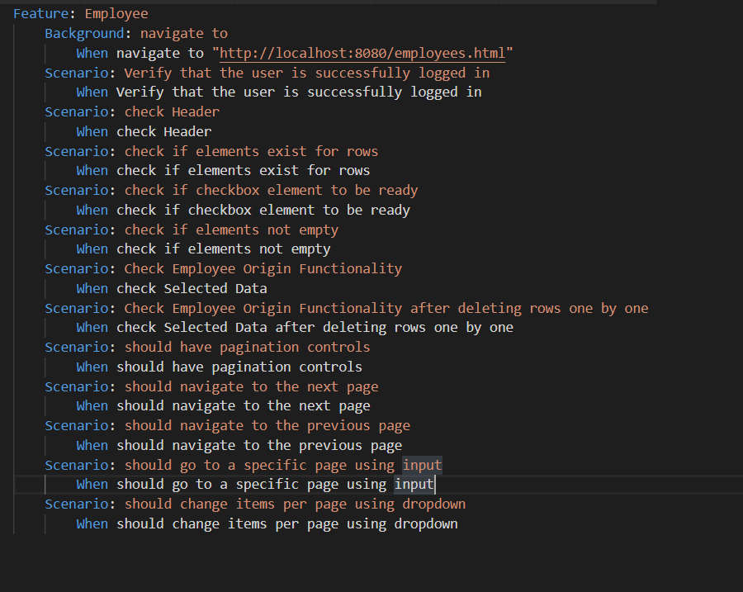

**Identified Issues:**

* **Authentication Functionality:**
  + **Problem:** The application consistently remains logged in, compromising security.
* **Header Column Order:**
  + **Problem:** The last column header should be "City" as per the requirement, but it may not be.

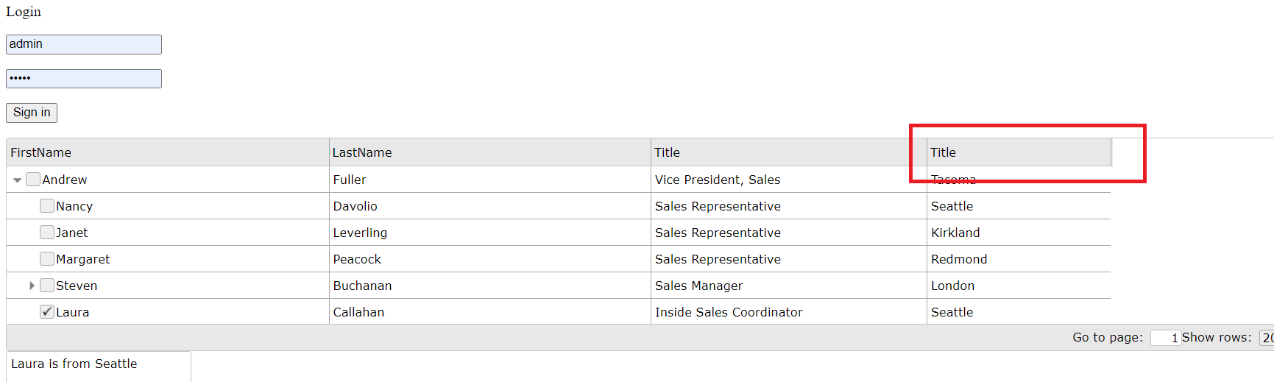

* **Empty City for Anne:**
  + **Problem:** The "City" column for the "Anne" row is empty.

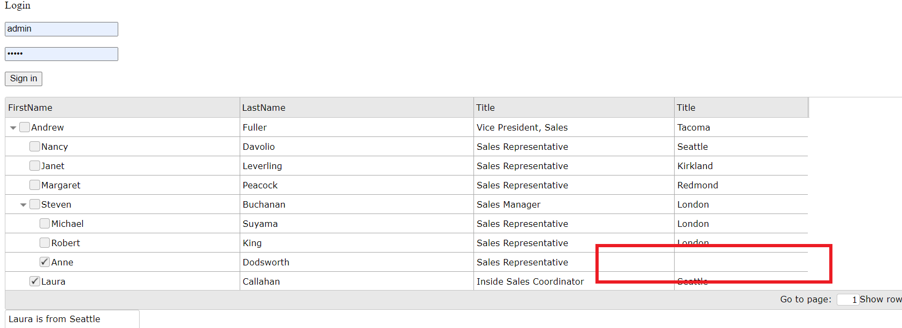

* **Pagination Dropdown Unresponsiveness:**
* **Problem:** Clicking on the "Show rows" dropdown and selecting a different value (e.g., 5) doesn't update the table result as expected.
* **Steps to Reproduce:**
  + Go to the "Show rows" dropdown button.
  + Choose the value 5.
* **Expected Result:**
  + The table should display the first 5 rows corresponding to the selected value.

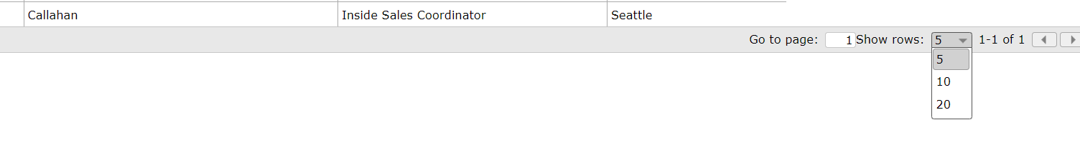

* **Multiple Next and Previous Buttons:**
  + **Problem:** There are two sets of Next and Previous buttons one hidden and another visible.

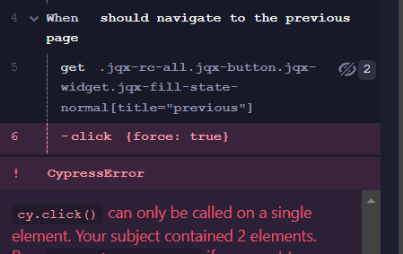

**Acceptance criteria**

Agree with acceptance criteria. Suggest adding tests for unsuccessful logins, dynamic header verification, handling empty data, and responsiveness of dropdowns for a more comprehensive testing approach.

**Test automation implementation**

Please find the implemented code on GitHub: GitHub Repository Link.

Steps to run the tests:

* Run **npm i** to install dependencies.
* Start the HTTP server using **http-server -c-1**.
* Execute **npx cypress run** or **npx cypress open**.
* View the Allure report for detailed results.

